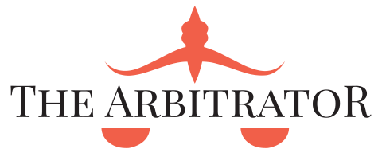
Mediation Agreement

December 21, 2015
The Arbitrator
P.O. Box 2477, Basseterre, St. Kitts

File No: ______________

BETWEEN

PARTY A

AND

PARTY B

The parties agree to participate in mediation to attempt to settle, compromise or resolve their dispute in relation to the above-noted matter either in whole or in part.
The provisions of the Agreement are as follows:
1. The Mediator is a neutral facilitator who will assist the parties in reaching their own settlement. The Mediator will not make any decision for the parties on how the matter must or should be resolved.
2. All written and oral communications made in the course of the mediation will be treated as confidential and without prejudice. Therefore:
a) The parties to this agreement agree that communications and documents shared in this mediation will not be disclosed to anyone who is not a party to this mediation.
b) The parties to this agreement agree that all communications made and documents shared in this mediation, which are not otherwise discoverable, will be shared on a without prejudice basis and, and will not be used in cross examination, at trial or in any other way, in this or any other proceeding
c) Everyone signing this document, whether or not a party to the litigation, agrees to be bound by the confidentiality provision of this agreement. Any individual signing on behalf of a corporation represents that he or she has authority to bind the corporation to the confidentiality provisions in this agreement.
3. The Mediator will not reveal the names of parties or anything discussed in Mediation except that the Mediator may disclose such information:
a) to the lawyers or other professionals retained on behalf of the parties as deemed appropriate or necessary by the mediator;
b) where ordered to do so by a judicial authority or where required to do so by law;
4. The parties agree that they will not at any time, before, during, or after mediation call the Mediator as a witness in any legal or administrative proceedings concerning this dispute.
5. While all parties intend to continue with mediation until a settlement agreement is reached, it is understood that any party may withdraw from mediation at any time.
6. If the Mediator determines that it is not practical or appropriate to continue the mediation, the mediator advise the parties accordingly and may terminate the process.
7. The parties or those representing them at the mediation have authority to settle the dispute.
8. The Mediator will not provide legal representation or legal advice to any party at any time, and has no duty to assert or protect the legal rights and responsibilities of any party, to raise any issue not raised by the parties themselves, or to determine who should participate in the mediation.
9. Where an agreement is reached, the parties or their counsel will draft any Settlement Documentation or Minutes of Settlement and any required releases.

I have read, understand and agree to the provisions of this Agreement signed this ______ day of ________________, 201___.
ON BEHALF OF PARTY A
I have the authority to bind the company.

______________________________
(SIGNATURE)
______________________________
(PRINT NAME)

ON BEHALF OF PARTY B
I have the authority to bind the company.

______________________________
(SIGNATURE)
______________________________
(PRINT NAME)
______________________________
[ATTORNEY FOR PARTY A]
______________________________
[ATTORNEY FOR PARTY B]
______________________________
MEDIATOR: [MEDIATOR NAME]

______________________________
DATE

